23.90: For an infinitesimal slice of a finite cylinder, we have the potential:

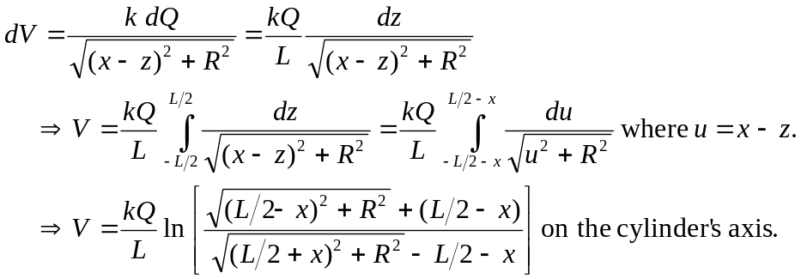

b) For 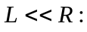

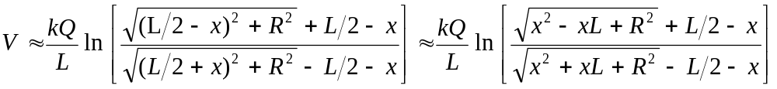
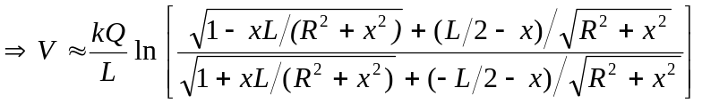
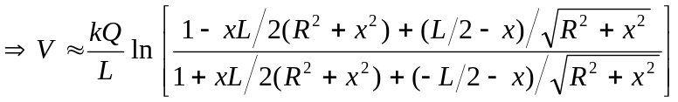
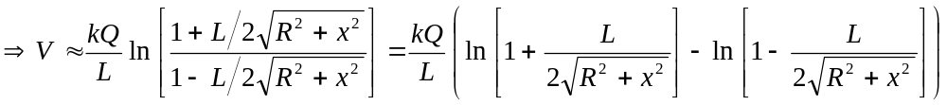
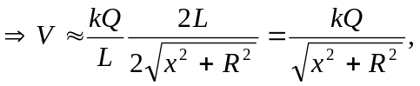 which is the same as for a ring.
c) 